**TITLE OF PROJECT:**

**E-Commerce Shopping Site**

MID TERM REPORT

by

**NAME OF THE CANDIDATES**

DEEPAK KUMAR (Section: K17CQ) (Roll Number: 38)

MANIK DAHUJA (Section: K17CQ) (Roll Number: 40)

[](https://www.google.co.in/url?sa=i&rct=j&q=&esrc=s&source=images&cd=&cad=rja&uact=8&ved=2ahUKEwjkz8H0-cbaAhUHP48KHWEIDUUQjRx6BAgAEAU&url=http://www.livelaw.in/lpus-1st-youth-vibe-national-moot-court-competition-2016/&psig=AOvVaw2hRojBLtKLfZF0zCF9iSYK&ust=1524248394115144)

**Department of Intelligent Systems**

**School of Computer Science Engineering**

**Lovely Professional University, Jalandhar**

Month-Year: SEPTEMBER 2019

**Student Declaration**

This is to declare that this report has been written by me/us. No part of the report is copied from other sources. All information included from other sources have been duly acknowledged. I/We aver that if any part of the report is found to be copied, I/we are shall take full responsibility for it.

Signature of Student

DEEPAK KUMAR

Roll number: 38

Registration Number:11703019

Signature of Student

MANIK DAHUJA

Roll number: 40

Registration Number:11703070

Place: **Lovely Professional university**

Date: **16-09-19**

**TABLE OF CONTENTS**

* **Background & Objectives of the Project**
* **Description of the Project**
* **Description of Work Division**
* **Working of the Project**
* **Technologies & Framework Used**
* **Market Potential**

**Background and Objectives of the Project.** .

Objective:

To achieve a webpage on “E-COMMERCE SITE “.

Containing:

* Home page
* Login form
* Registration form
* Feedback form
* Contact us form
* About us page

Background:

Code used:

* HTML
* CSS
* JavaScript

Motivation:

We have taken the motivation of this project from the well known E-commerce website FLIPKART.

Outcome of the Project:

The outcome of this project is that user must see the products available in the website and book those products.

**Description of Project**

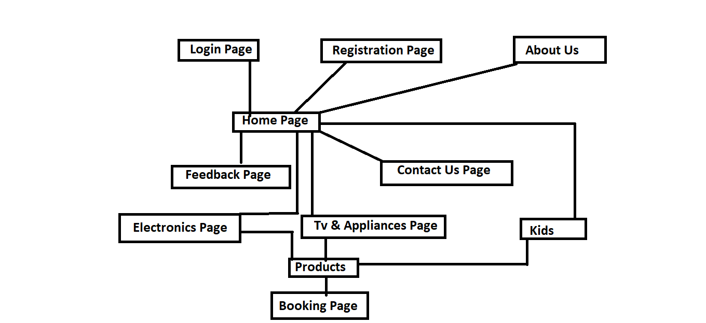

**Description of Work Division**

-> NAME: DEEPAK KUMAR

ROLL NO: 38

He has designed:

* LOGIN PAGE
* HOME PAGE
* ELECTRONICS PAGE
* KIDS PAGE
* REGISTRATION PAGE
* TV & APPLIANCES
* BOOKING PAGE

-> NAME: MANIK DAHUJA

ROLL NO.: 40

He has designed:

* FEEDBACK PAGE
* CONTACT US PAGE
* ABOUT US PAGE
* MEN & WOMEN PAGE
* FOOTWEAR PAGE

**WORKING OF THE PROJECT**

HOME PAGE:

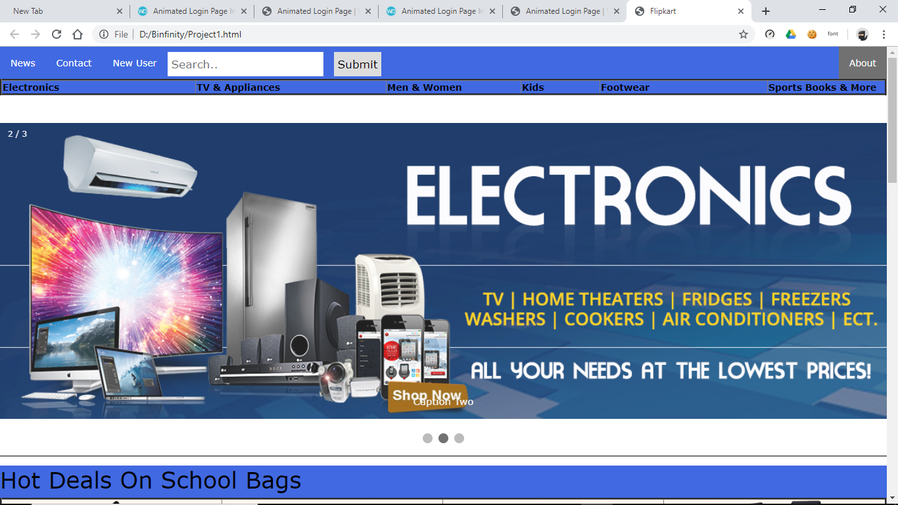

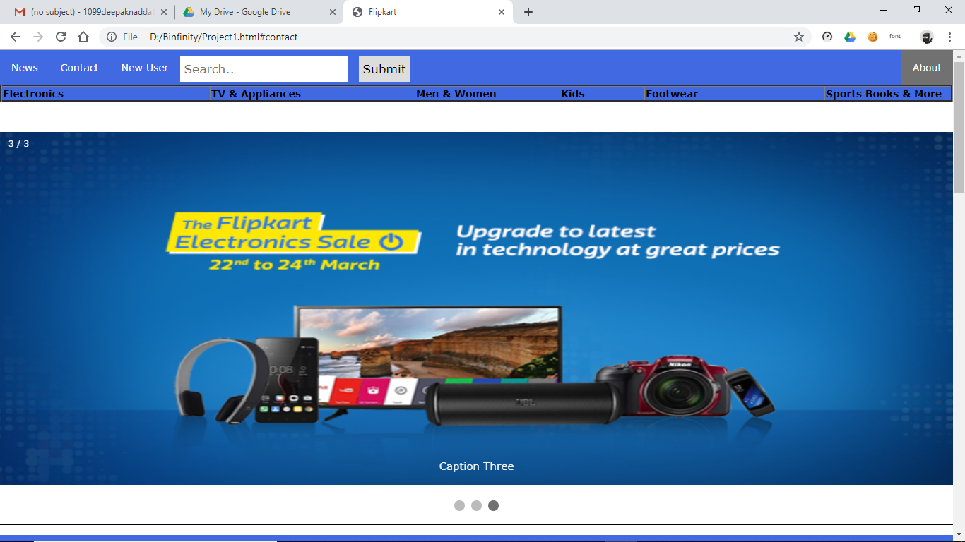

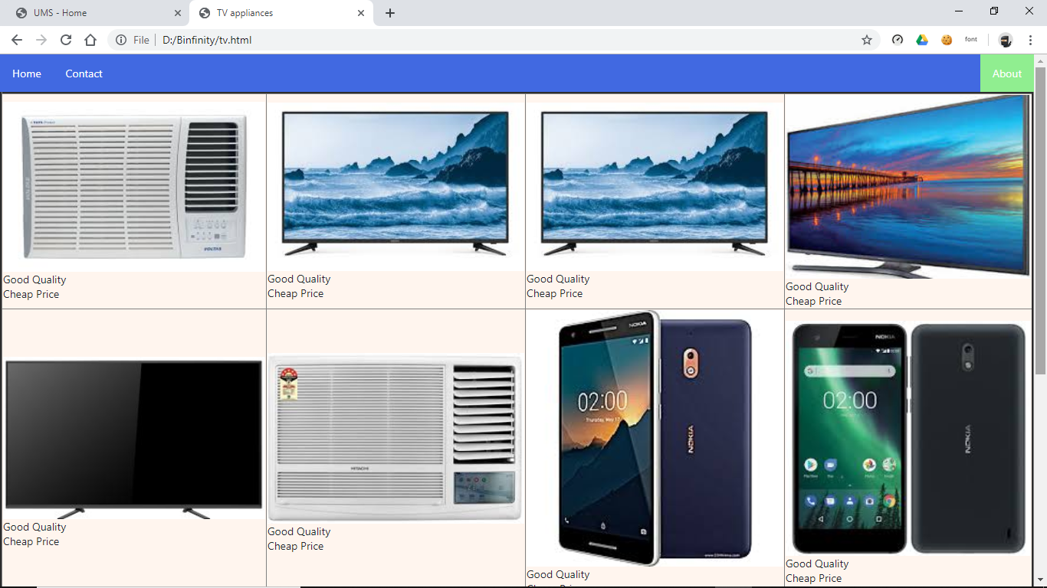

*The photos are placed by using<**table**> tag.

*The photo is designed by the use of **<photo>** tag.

*The heading of TV & APPLIANCES is made by **<h>** tag.

*The all orientation is display by the use of **CSS** file.

*The about us the link that connects you to the about us page.

HOME:

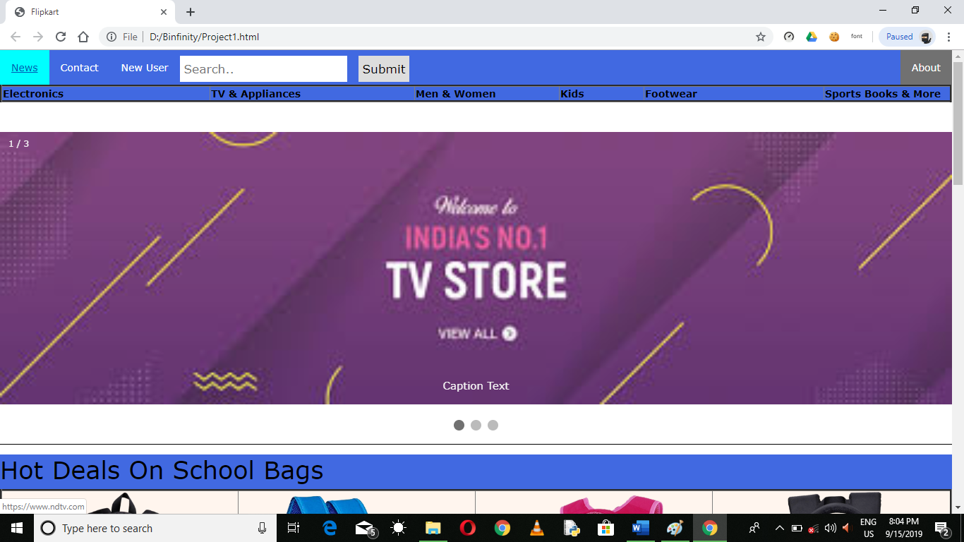

The colour is changing when cursor is placed made by on hover property of css. 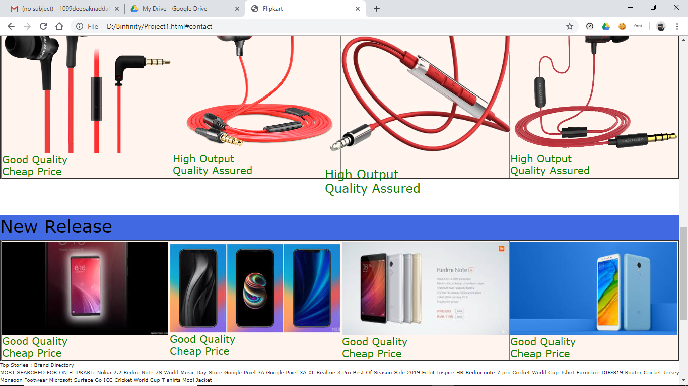

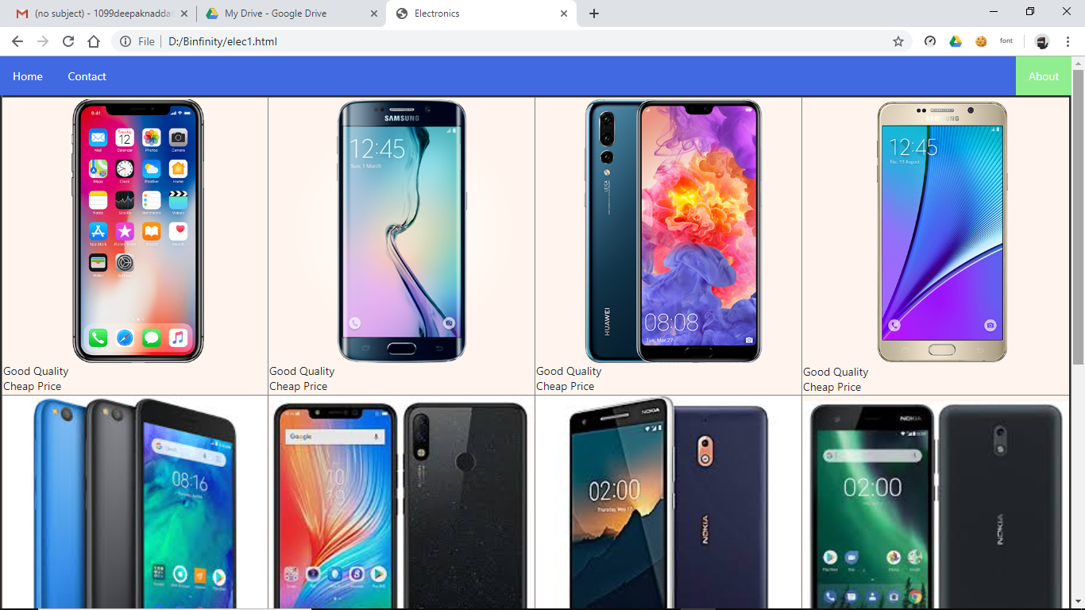

* Each page is linked with a **CSS** file which enable us put the image in the aligned manner.
* The content is putted in the <table> tags.

LOGIN PAGE: 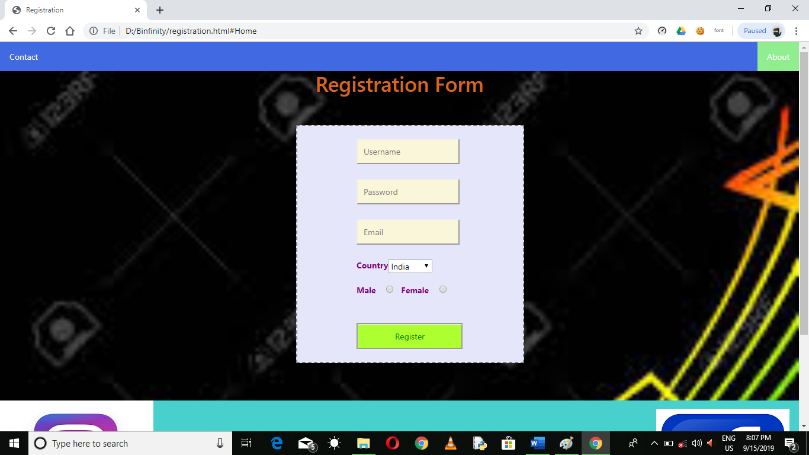

* The Registration form is created by using **HTML ,CSS** ,and **JAVASCRIPT**
* When you press Register button the form gets submitted.
* Username, Email ID , and Passwordis created by the use of **<input>** tag.
* The gender is made by the use of **<input>** tag.

ELECTRONICS PAGE:

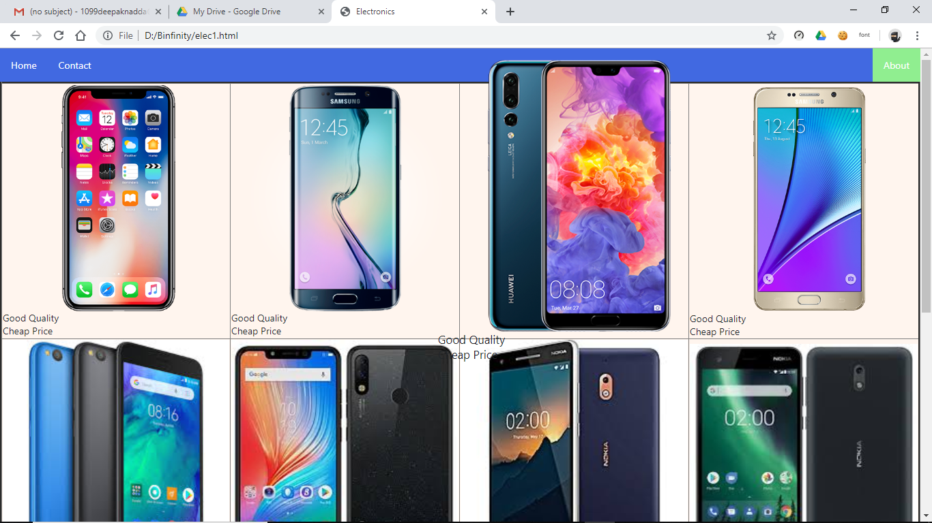

* The Electronics page is made in a similar ways as the rest of pages is made by the use of **CSS** file, **HTML**, and **JAVASCRIPT**

**Technologies and Framework:**

* **HTML:** Hypertext Markup Language (**HTML**) is the standard markup language for documents designed to be displayed in a web browser. It can be assisted by technologies such as Cascading Style Sheets (CSS) and scripting languages such as JavaScript.
* **CSS:** Cascading Style Sheets (**CSS**) is a stylesheet language used to describe the presentation of a document written in HTML or XML (including XML dialects such as SVG, MathML or XHTML). **CSS** describes how elements should be rendered on screen, on paper, in speech, or on other media
* **Javascript: JavaScript** (JS) is a lightweight, interpreted, or just-in-time compiled programming language with first-class functions. While it is most well-known as the scripting language for Web pages, many non-browser environments also use it, such as Node.js, Apache CouchDB and Adobe Acrobat.

**Market Potential**

The e-commerce has transformed the way business is done in India. The Indian e-commerce market is expected to grow to US$ 200 billion by 2026 from US$ 38.5 billion as of 2017. Much growth of the industry has been triggered by increasing internet and smartphone penetration. The ongoing digital transformation in the country is expected to increase India’s total internet user base to 829 million by 2021 from 604.21 million as of December 2018.  India’s internet economy is expected to double from US$125 billion as of April 2017 to US$ 250 billion by 2020, majorly backed by ecommerce. India’s E-commerce revenue is expected to jump from US$ 39 billion in 2017 to US$ 120 billion in 2020, growing at an annual rate of 51 per cent, the highest in the world.

#### **Market Size**

Propelled by rising smartphone penetration, the launch of 4G networks and increasing consumer wealth, the Indian e-commerce market is expected to grow to US$ 200 billion by 2026 from US$ 38.5 billion in 2017 Online retail sales in India are expected to grow by 31 per cent to touch US$ 32.70 billion in 2018, led by Flipkart, Amazon India and Paytm Mall.

During 2018, electronics is currently the biggest contributor to online retail sales in India with a share of 48 per cent, followed closely by apparel at 29 per cent.

#### **Investors In Market:**

* Flipkart
* Amazon